Database Management Systems

Lab 1

Nidhi Surya Prakash

SUID: 215895619

ER Diagrams: An entity relationship **diagram** (ERD) shows the relationships of entity sets stored in a particular database. An entity in this context is a component of data. In other words, **ER diagrams** illustrate the logical structure of databases.

Primary Key: Primary key uniquely identify a record in the table.

Foreign Key: Foreign key is a field in the table that is primary key in another table.

Cardinality:Cardinality specifies how many instances of an entity relate to one instance of another entity.

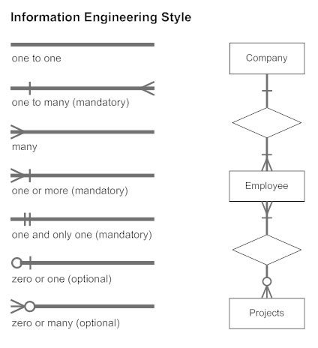

Problem Given: *Consider a hair salon business. The owner wants to keep track of the customers, their appointments, employees that perform the haircuts/services, products that the salon sells and of actual sales (for both haircuts and the products).*

Solution*:*

* According to the solution engineered, I have created 6 Tables

1. Customer

Keeps track of the Customer name, age, gender and their address. The primary key is Customer_ID

1. Appointment

Keeps track of all the appointments made by a customer using the primary key Appointment _ID. Also keeps trach of the time, date of appointment along with which employee has been assigned for that appointment (Emp_ID) and which service is required by the service using foreign key service_ID.

1. Employee

The employee table is to keep track of all the employees working at the salon. The primary key used here is Emp_ID. Employee is tracked by his/her name, gender, ratings provided by customers, his/her particular genres they are good at and the years of experience they have.

1. Services

The service table is mainly used to track what services the salon has provided the customers along with their bill amounts. Primary key used is is Service_ID and attributes here include bill total and category, or type or service provided.

1. Sales

Sales table is used to keep track of all the products bought by a customer, quantity available or bought and the total sales of each. Primary key used is Sales_ID with foreign keys Prod_ID and Appointment_ID.

1. Products

To keep track of all products available with name, their brand, expiration dates, cost, quantity available to sell. Primary key is Prod_ID.

Relations/Cardinality

1. Customer <-> Appointment

Customer can make zero or more appointments

Each appointment can have one and only one customer related to it.

1. Appointment <-> Employee

Each employee is assigned one or more appointments

Each appointment can have 1 or more employees working on it.

1. Appointment <-> Sales

Each sale can have one appointment associated to it.

Each appointment can have zero or more sales.

1. Sales <-> Products

Each product can have 0 or more sales to a customer

Each sale can have zero or more products sold and recorded.

1. Appointment <-> Services

Each service provided can have one appointment ID assigned to it to keep track of the total amount cost of a customer

Each appointment can have 1 or services required to be fulfilled.

References:

1. <https://www.dotnettricks.com/learn/sqlserver/difference-between-primary-key-and-foreign-key>
2. https://www.smartdraw.com/entity-relationship-diagram/